Jaclyn Paez
Workshop 6 (screen shots of work)

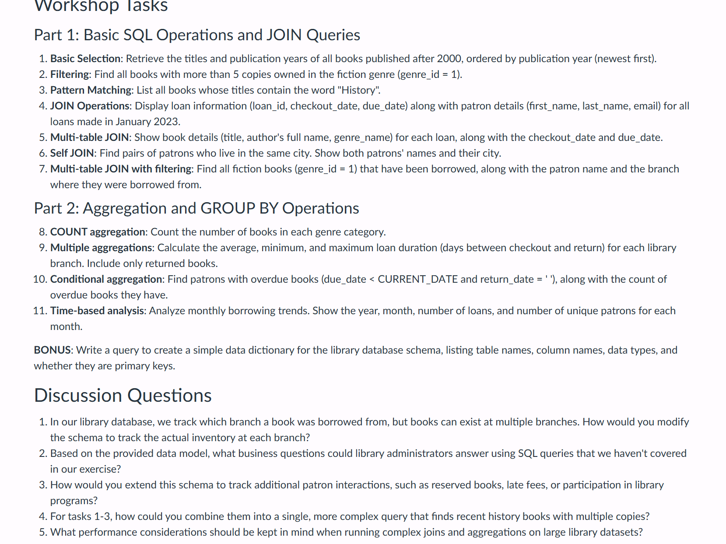

Question 1:

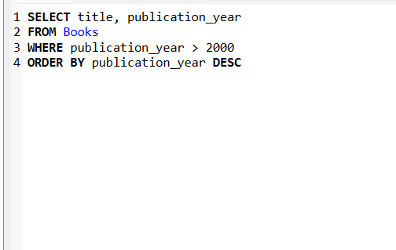

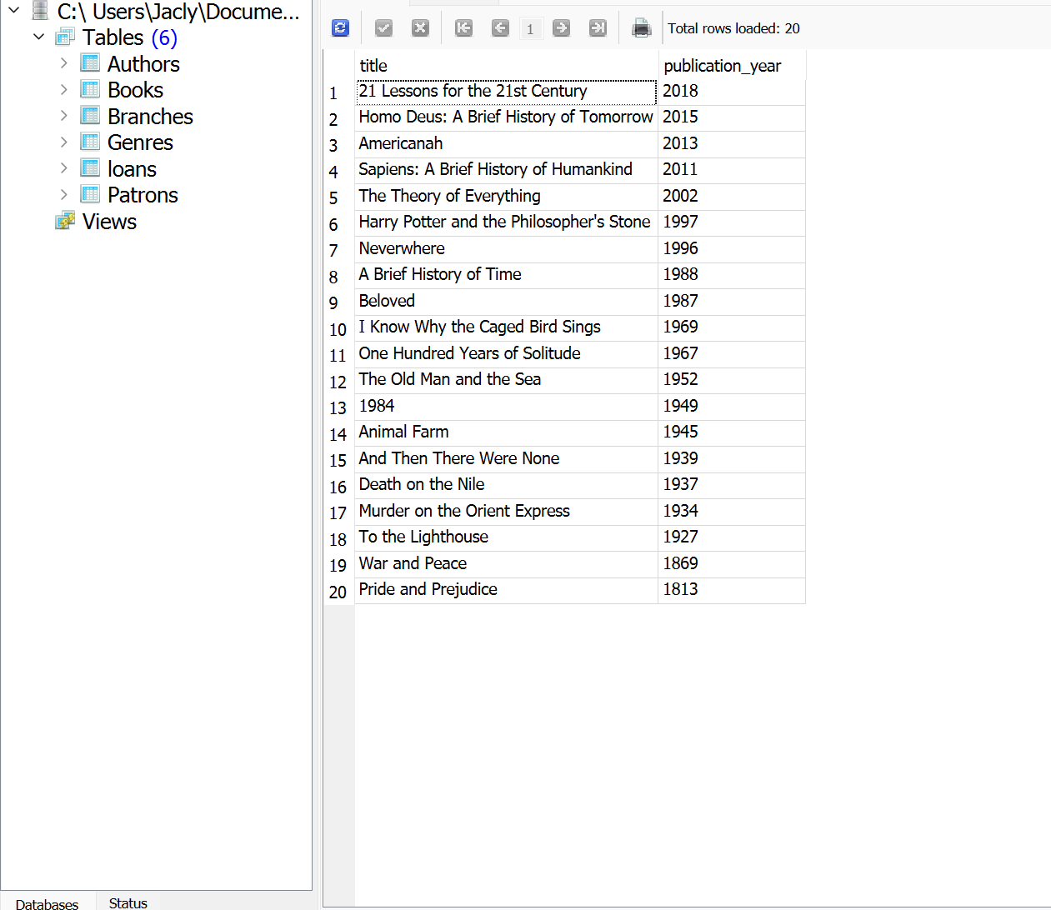

Question 2:



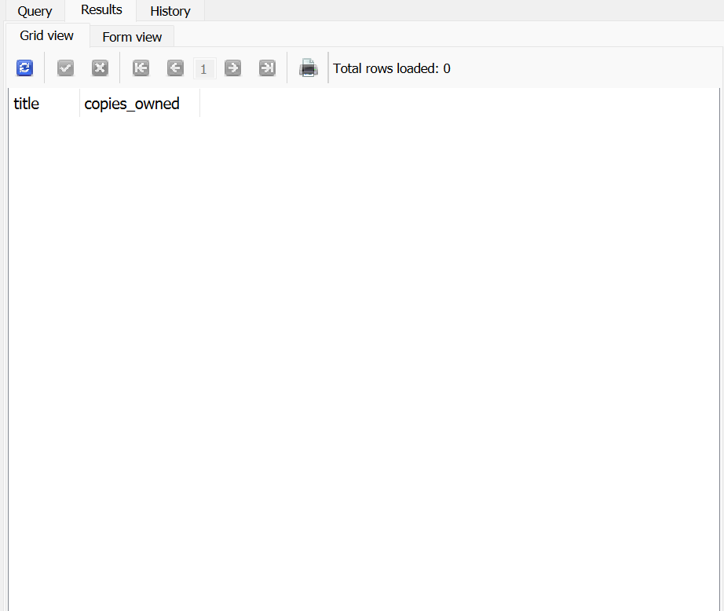

Question 3

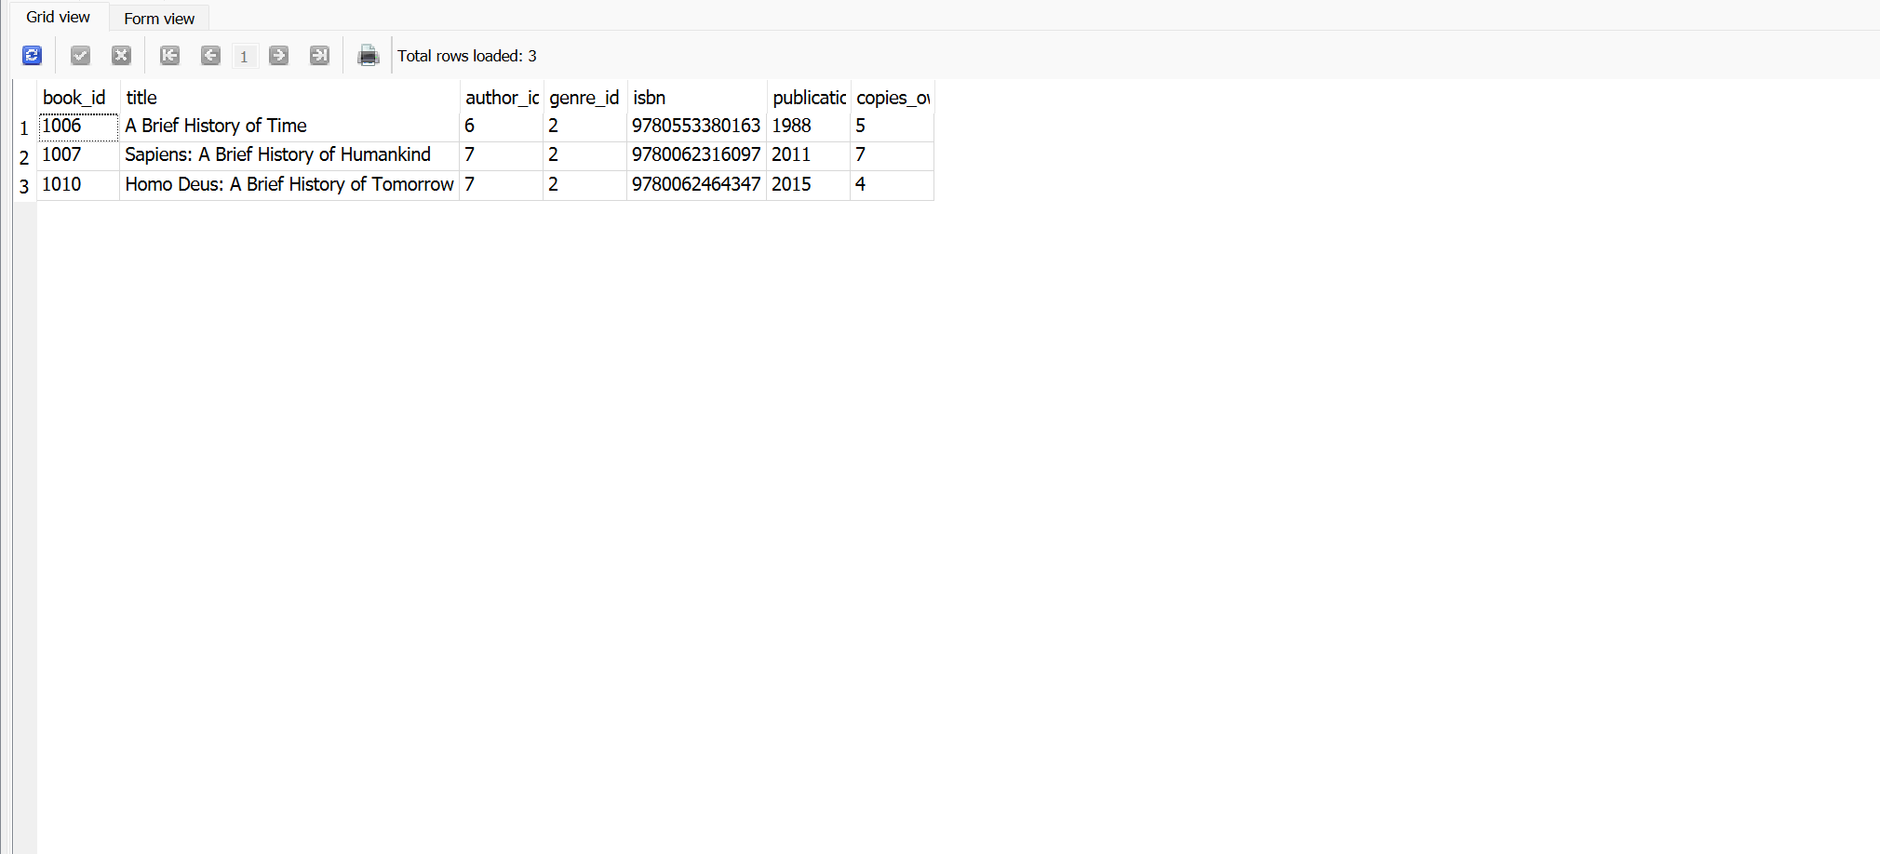
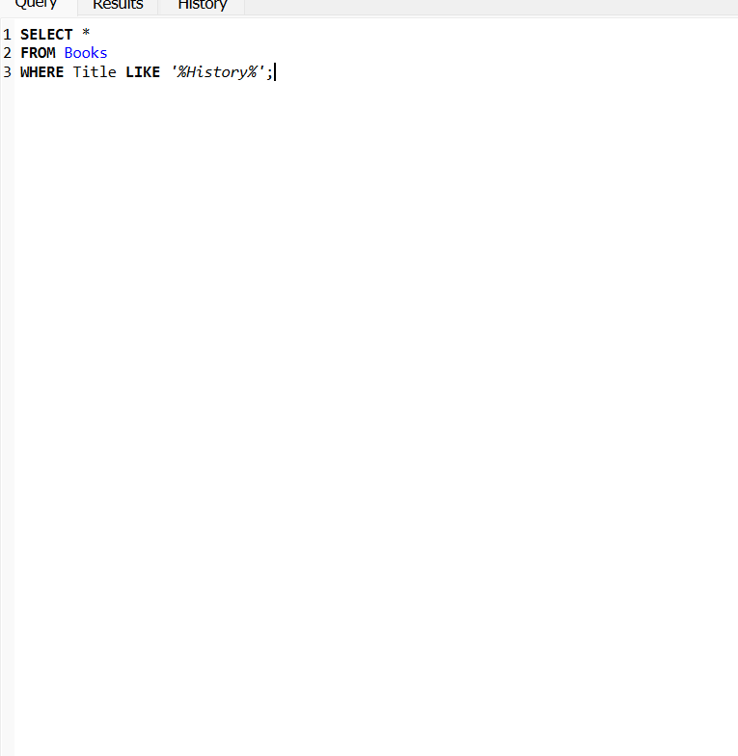

Query 4: 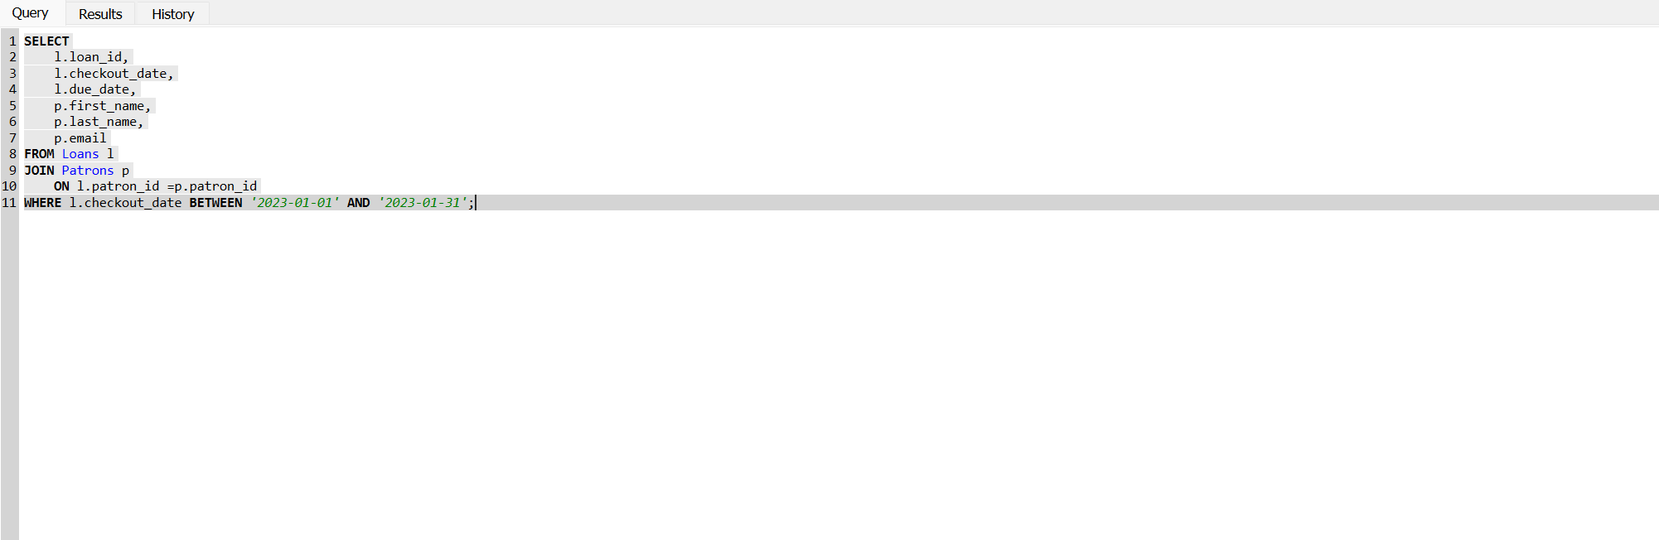

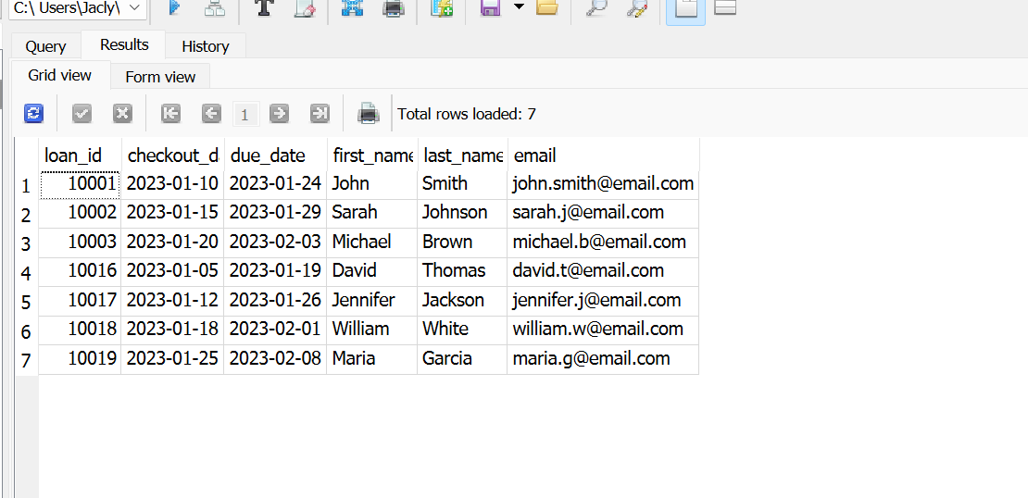

Question 5
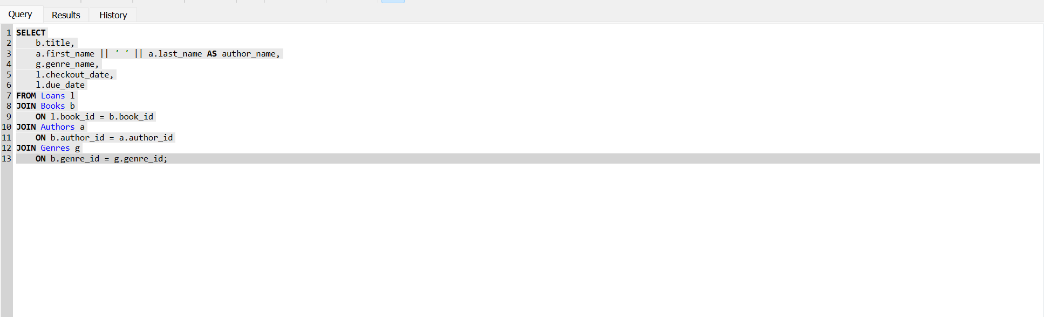

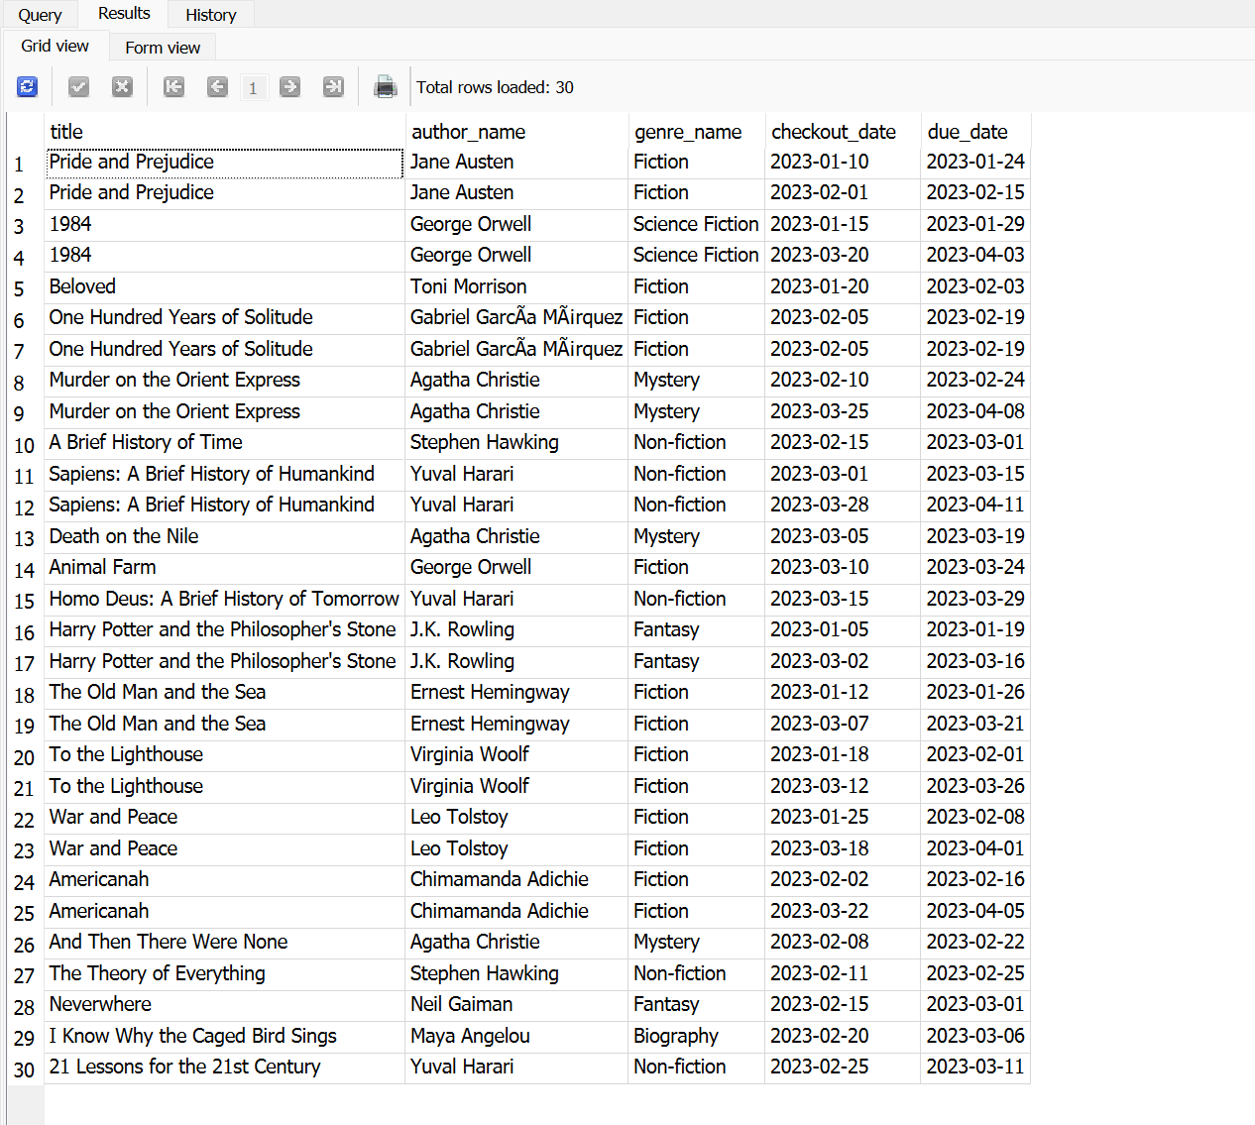

Question 6

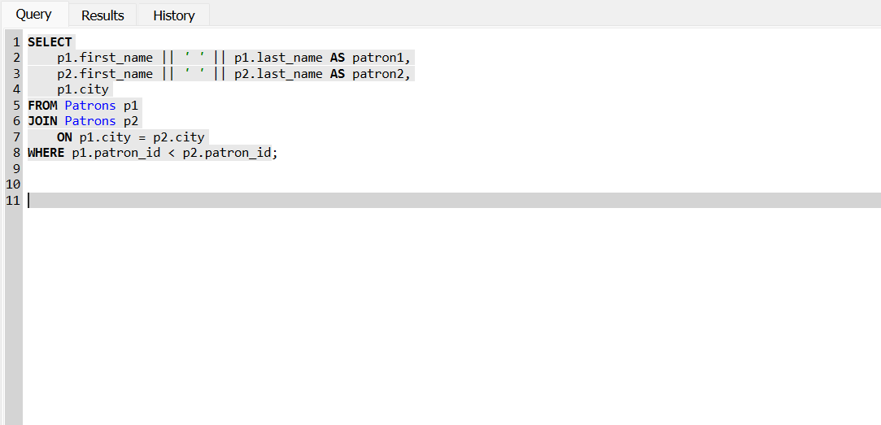

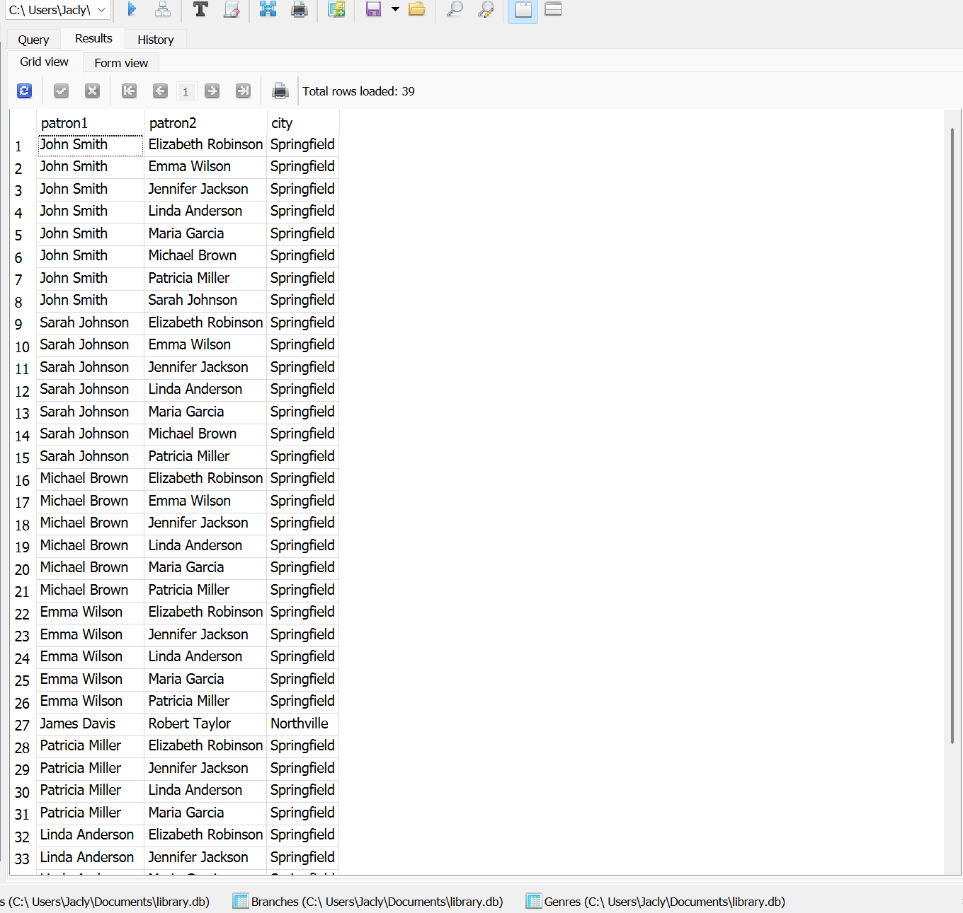

Question 7

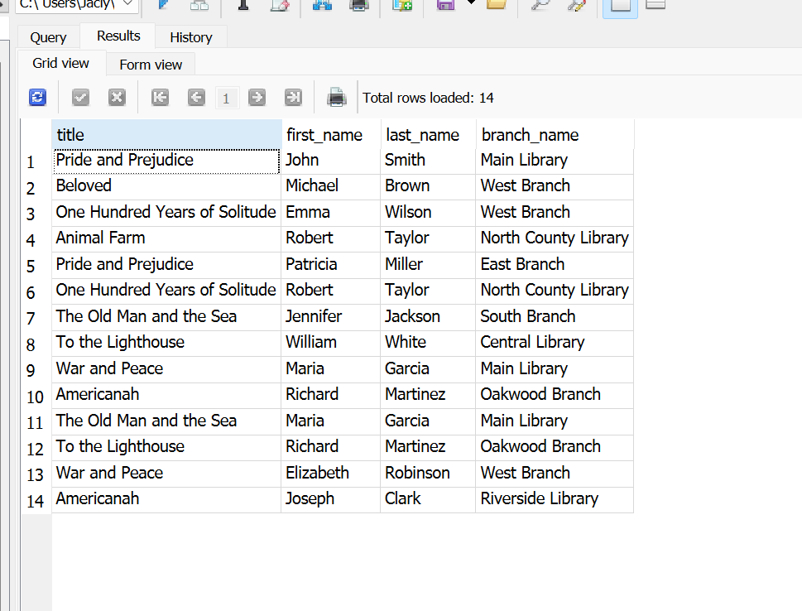

Question 8

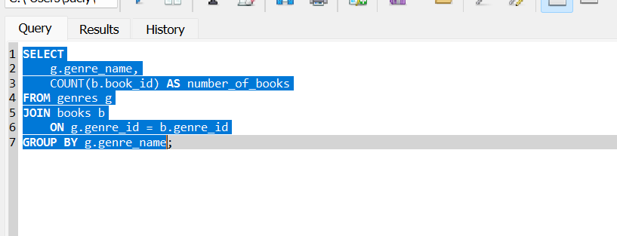

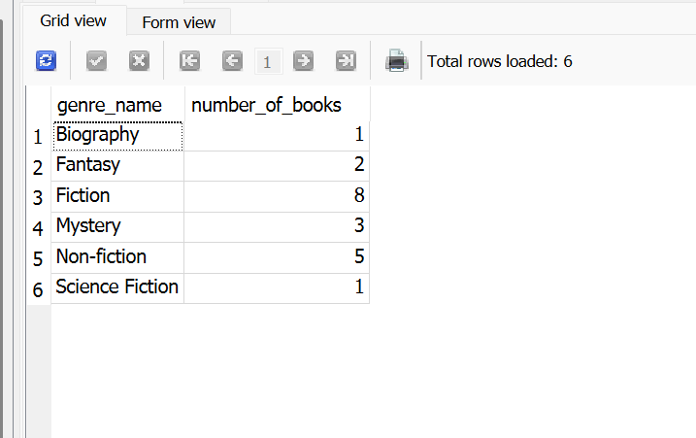

Question 9
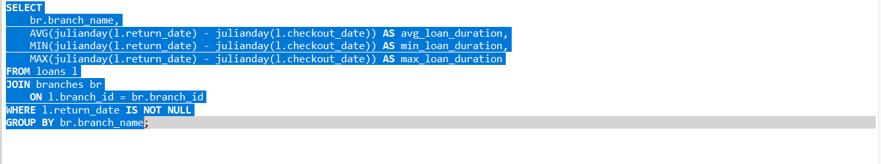

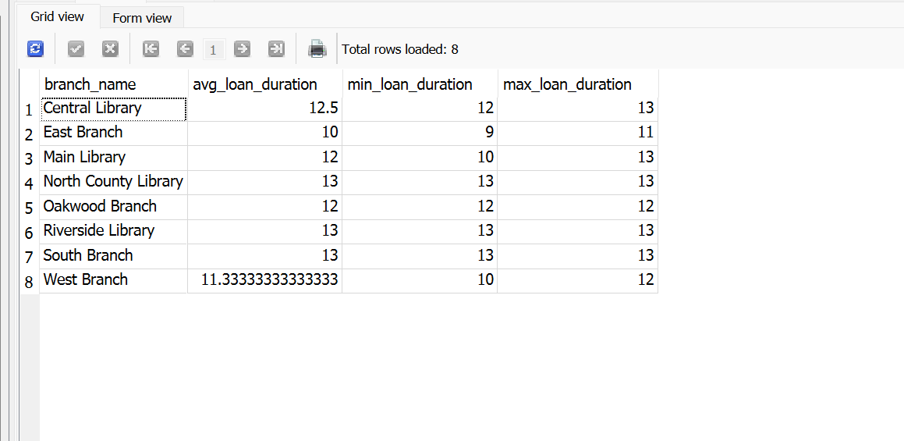

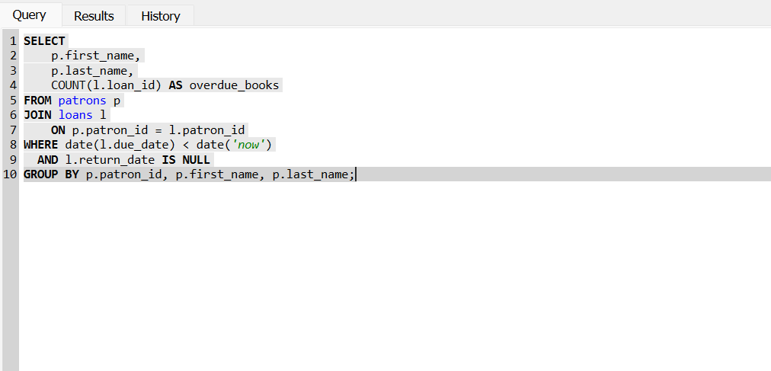
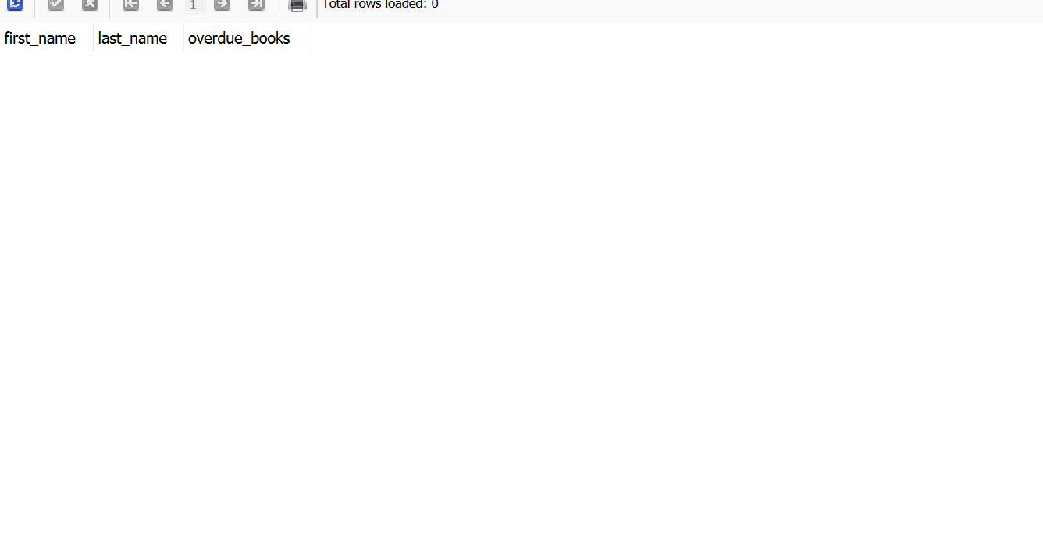
Question 11
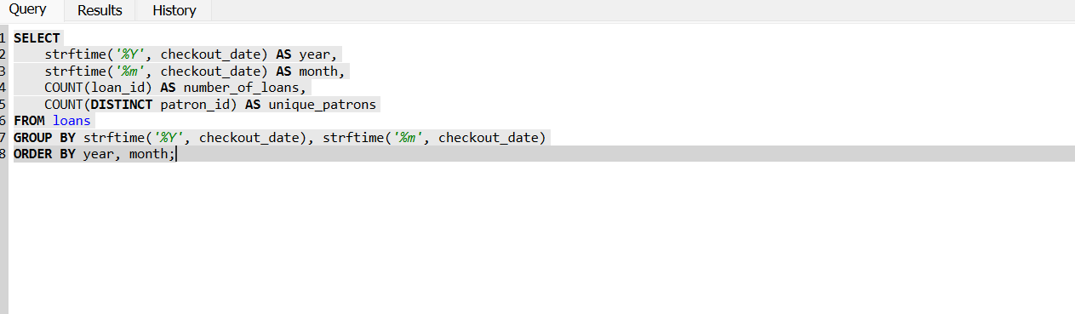

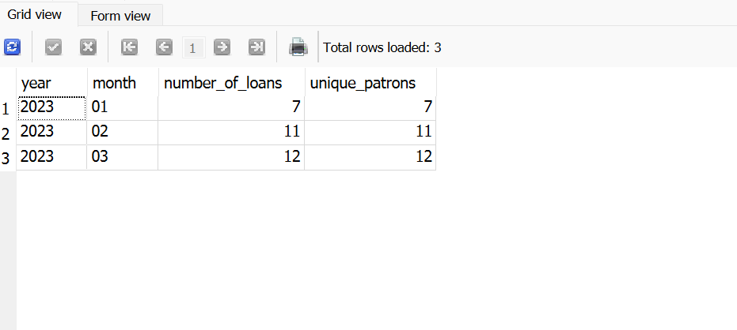

Discussion Answers:
1. In our library database, we track which branch a book was borrowed from, but books can exist at multiple branches. How would you modify the schema to track the actual inventory at each branch?
I would create a separate inventory table that connects books and branches. This table could include the number of copies available at each branch and whether copies are currently checked out. That would make it easier to manage inventory across multiple locations.
2. Based on the provided data model, what business questions could library administrators answer using SQL queries that we haven’t covered?
Library administrators could identify the most popular books and authors, see which branches have the highest borrowing activity, determine which patrons borrow books most often, and analyze seasonal borrowing trends to help with planning and purchasing new books.
3. How would you extend this schema to track additional patron interactions, such as reserved books, late fees, or participation in library programs?
I would add separate tables for reservations, late fees, and library programs. Each table could be linked to the patron ID so the library can keep track of reservations, outstanding fees, and which programs each patron has attended.
4. For tasks 1–3, how could you combine them into a single, more complex query that finds recent history books with multiple copies?
I would use a query that joins the books and genres tables, filters for books published after 2000, searches for titles containing “History,” and only returns books with more than five copies. This would combine filtering, pattern matching, and multiple conditions into one query.
5. What performance considerations should be kept in mind when running complex joins and aggregations on large library datasets?
To improve performance, I would make sure the tables have indexes on commonly used columns like IDs and dates, only select the columns that are needed instead of using SELECT *, and avoid unnecessary joins. These practices help queries run more efficiently as the database grows.

